CAPPA Social Media Rapid Response Toolkit
Topic: Emergency Child Care Vouchers
April 3, 2020

Background: Since the COVID 19 Pandemic crisis essentially shut down much of California’s economy and society in mid-March, not a single additional fund was allocated to serving the dire unmet need of the essential workforce in the state. With the passage of the federal CARES Act on March 27th, $3.5 billion was committed in new Child Care and Development Block Grant (CCDBG) funding, with $339 million earmarked for California. We need an immediate release of Federal funds, and the creation of an emergency childcare voucher program to serve the dire unmet need of the essential workforce in California.

Objective: Encourage the CA Legislature and Governor Newsom to fund an emergency child care voucher program with an immediate release of newly allocated CCDBG funds from the federal Coronavirus Relief Package (the CARES act).

What to do:
- Contact your elected officials in the State Assembly and Senate. You can find out your representatives here. Need help finding out who to reach out to? Contact Donna at Donna@cappaonline.com.
- Take to social media! Sample tweets are below. You can find your legislator’s twitter handle on the spreadsheet linked here.
- Email your elected officials with this request. Sample email is below.

Sample Tweets:
- #FACT: Since the #COVID19 crisis began, #CA has seen ZERO additional funds directed to #childcare. Providers are ready to serve: we need to #ReleasetheFunds and meet the unmet need of #EssentialWorkers! #FundChildCare
CLICK TO TWEET
- #EssentialWorkers are on the front lines fighting the #COVID19 pandemic, and their children need care. Lets #ReleasetheFunds to serve #California’s families in need!
CLICK TO TWEET
- Here in ________ county, families urgently need #childcare relief. <YOUR ELECTED OFFICIAL>, can you commit to supporting #EssentialWorkers & their families and implement an #EmergencyChildcareVoucher program NOW?
- We were in a #childcare crisis in #CA before the #Covid19 pandemic, and the need just got critical. @CAGovernor @GavinNewsom – let’s #ReleasetheFunds and implement emergency child care vouchers NOW!
CLICK TO TWEET
- What do families need? Access to #EmergencyChildcareVouchers! When do they need it? YESTERDAY! Tell @CAGovernor @GavinNewsom: #EssentialWorkers & their families can’t wait.
CLICK TO TWEET

Sample Images to Share (download to your computer first):

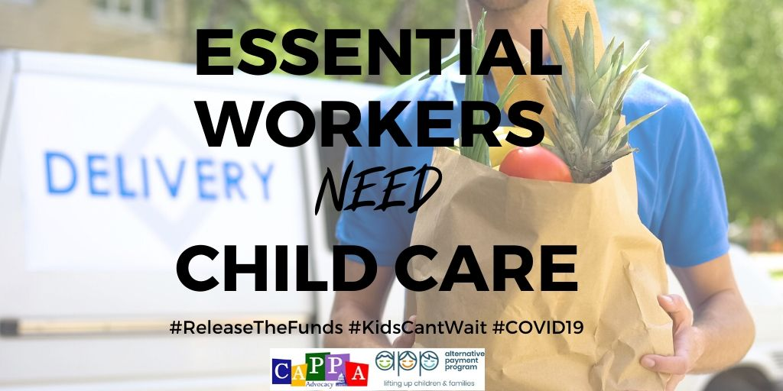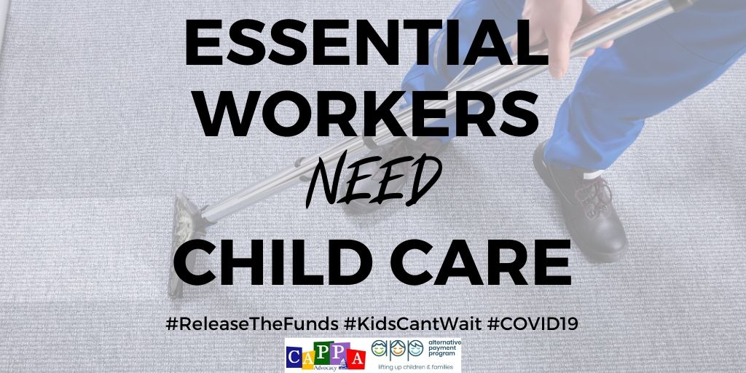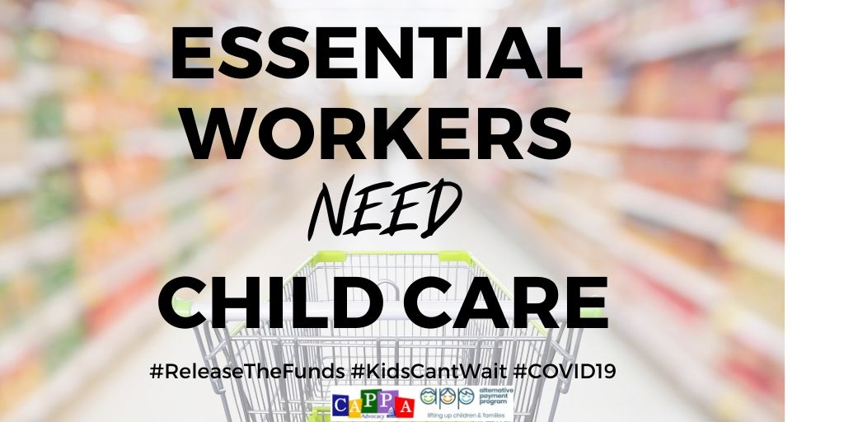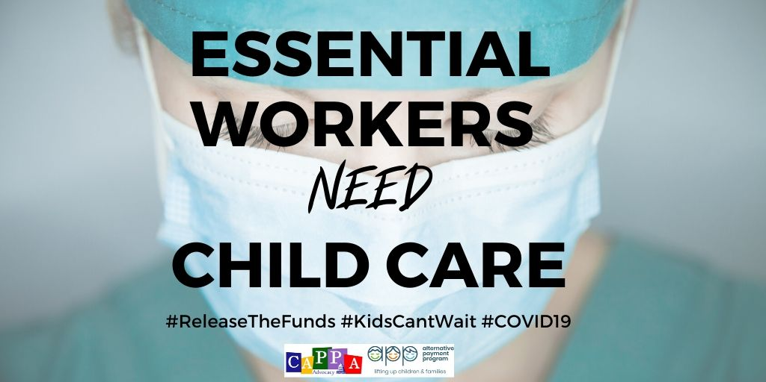

TEMPLATE <INSERT YOUR LETTERHEAD HERE>

Sample Email/ Letter:

Dear Assemblymember/Senator <Last Name>,

I represent <YOUR AGENCY> in <YOUR COUNTY>. We serve XXX families daily by providing
subsidized child care for working families across the state. <Provide a sentence or two regarding specific services provided by you> .

As you know, on March 20th, 2020, Governor Gavin Newsom issued Executive Order (EO) N-33-20, a statewide shelter in place policy which mandated social distancing across the state to better combat the spread of COVID-19. These EO also made clear that only an “essential workforce” could continue to work as usual, consisting of those in the medical and healthcare sector, law enforcement, food, shelter and social services. Further, it was clarified on the COVID19 homepage that “daycares are still open, but only for children of parents working in essential sectors.”

Now that we are in April, we must underscore what “daycare” capacity exists to support these essential workers – Family Child Care Homes (FCCHs), Family, Friend and Neighbor (FFN) care, and a limited number of centers. And it must be underscored that this existing capacity is very fragile due to inconsistent messaging that has gone out to the field and the lack of access and funding for basic supports such as cleaning supplies, toiletries and diapers

Since the start of this crisis, no additional child care slots have been added for essential workers to access child care.

The childcare workforce is the backbone that will support getting us through this crisis, but providers need to be funded to do so. On March 27th, $339million was earmarked for California via the federal CARES act, and we are asking that funds be immediately directed towards supporting the unmet need of essential workers for childcare by implementing an Emergency Child Care Voucher Program so that they can continue working on the front lines of the COVID-19 crisis.

Thank you for your consideration of this urgent request. Please feel free to contact me at <YOUR INFORMATION> for more information on how this crisis is impacting families in your district.

Thank you,

<Your Name>

